class4jan16th.R

zaina

2025-01-16

x <- 1:50  
plot (x, sin(x))

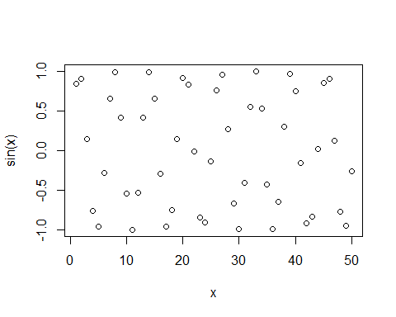

#Make this nicer  
plot(x, sin(x), col ="blue", type ="l", lwd=3)

